REVERSE CAR PARKING SYSTEM

1. **MINI-PROJECT REPORT**

***Submitted by***

|  |  |
| --- | --- |
| **ROSHINI RAJA** | **2116210701216** |
| **KAJA MOHIDEEN** | **2116210701514** |

***in partial fulfillment of the award of the degree***

***of***

**BACHELOR OF ENGINEERING**

**IN**

**COMPUTER SCIENCE ENGINEERING**



**RAJALAKSHMI ENGINEERING COLLEGE,**

**AUTONOMOUS: CHENNAI 600 025**

# RAJALAKSHMI ENGINEERING COLLEGE CHENNAI

**BONAFIDE CERTIFICATE**

Certified that this project “**REVERSE CAR PARKING SYSTEM** ” is the bonafide work of “ ROSHINI RAJA (211621070216) , KAJA MOHIDEEN (2116210701514) ” who carried out the project work under my supervision.

SIGNATURE

Mrs.Anitha Ashishdeep(M.Tech)

Assistant Professor

Department of Computer Science and Engineering

Rajalakshmi Engineering College

Chennai - 602 105

**Submitted to Project Viva-Voce Examination held on _______________________**

**Internal Examiner External Examiner**

## 

## ACKNOWLEDGMENT

Initially we thank the Almighty for being with us through every walk of our life and showering his blessings through the endeavor to put forth this report. Our sincere thanks to our Chairman Mr. S.MEGANATHAN, B.E, F.I.E., our Vice Chairman Mr. ABHAY SHANKAR MEGANATHAN, B.E., M.S., and

our respected Chairperson Dr. (Mrs.) THANGAM MEGANATHAN, Ph.D., for providing us with the requisite infrastructure and sincere endeavoring in educating us in their premier institution.

Our sincere thanks to Dr. S.N. MURUGESAN, M.E., Ph.D., our beloved Principal for his kind support and facilities provided to complete our work in time. We express our sincere thanks to Dr.P.KUMAR, Ph.D., Professor and Head of the Department of Computer Science and Engineering for his guidance and encouragement throughout the project work. We convey our sincere and deepest gratitude to our internal guide, Mrs.Anitha Ashishdeep ( Department of Computer Science and Engineering, Rajalakshmi Engineering College for her valuable guidance throughout the course of the project.

ROSHINI RAJA

KAJA MOHIDEEN

**ABSTRACT**

In this modern era, the current technological developments provide greater facilities for human life. We can find the technological developments in many

fields including automobile field. Over the past few years, transportation has

become one of the most necessary and basic facilities for human life. With the

enlargement of automobile field the number of vehicles owned by people are also increasing, especially cars are greatly increasing nowadays. Most of the accidents occurred while parking the cars in a place. This project proposes to design a simple reverse car parking system to park the car in a safe way without any damage or creating accidents. In this design, the car parking distance is controlled by using an ultrasonic sensor and this design can be incorporated inside the dashboard of the car. In this design Arduino UNO, Ultrasonic sensor are the main components and LED, Buzzer is used for indication for the persons who are driving. This design can make easy for the drivers to park the car in reverse without any damage

**TABLE OF CONTENTS**

|  |  |  |
| --- | --- | --- |
| CHAPTER NO | TITLE | PAGE NO |
|  |  |  |
| 1 | INTRODUCTION | 1 |
|  |  |  |
| 2 | LITERATURE SURVEY | 2 |
|  |  |  |
| 2.1 | EXISTING SYSTEM | 3 |
|  |  |  |
| 3 | PROJECT DESCRIPTION | 4 |
|  |  |  |
| 3.1 | PROPOSED SYSTEM | 6 |
|  |  |  |
| 3.2 | REQUIREMENTS | 6 |
|  |  |  |
| 3.2.1 | HARDWARE REQUIREMENTS | 6 |
|  |  |  |
| 3.2.2 | SOFTWARE REQUIREMENTS | 6 |
|  |  |  |
| 3.3 | ARCHITECTURE DIAGRAM | 7 |
|  |  |  |
| 3.4 | OUTPUT | 8 |
|  |  |  |
| 4 | CONCLUSION AND FUTURE WORK | 11 |
|  |  |  |
|  | APPENDICES | 12 |
|  |  |  |
|  | REFERENCE | 14 |
|  |  |  |

iv

**CHAPTER 1**

**INTRODUCTION**

India is one of the fastest growing economies in the world. In this modern era, technological developments have been rapidly increasing as it provides facilities for human life. There are many technological developments including in the field of automobiles. The enlargement of the automobile field has increased the usage of vehicles especially cars in the urban areas. The average income of Indians is growing and thereby the number of privately owned vehicles is rising. Car Parking is the major problem in urban areas of both developed and developing countries.

Nowadays parking a car is one of the important skill for drivers as well as car

owners as it is very difficult to park in a small space. Reverse parking in a

a congested place or in a small space is very difficult. Around 30 percent of car accidents are caused while parking. To solve this our project proposes to design a simple reverse car parking system to park the car in a safe way without any damage or creating accidents.

1

**CHAPTER 2**

**LITERATURE SURVEY**

**1. Use of Modern Technology in Reverse Car Parking System**

**Author and Year :** Farman Ali, Muhammad Athar Suri, International Journal

of Computer Engineering and Information Technology, March 2016.

They implemented this system by using ultrasonic sensor which produces

pulses that estimates the distance between the device and the object that can be

calculated which uses microcontroller and based on the distance interval LED

indication and buzzer indication which can be used for reverse parking system.

**2. Reverse Car Parking Sensor**

**Author and Year :** Sawant Sarvesh Shashikant Smruti, Arakade Aditya Vijay

Chhaya,International Research Journal of Engineering and Technology (IRJET),April 2021.

They developed a Parking Sensors which is used to identify the nearby vehicle

parking. It is designed Arduino UNO with transistors and diodes which has

buzzer also to indicate the critical distances. This can be used as driver

assistance system.

**3. The Smart Parking System Using Ultrasonic Control Sensors**

**Author and Year :**YousifAllbadi, Jinan N. Shehab, Musaab M. Jasim, IOP

Conference Series Materials Science and Engineering, February 2021. This paper presents asmart parking system using infrared and ultrasonic sensors, which is controlled by Arduino Mega 2560. The Radio Frequency Identification (RFID) reader provides authorization to enter the smart parking system. This smart parking system is implementing in a small-scale model, and the results show that simulates the car parking with the mobile application, all the sensors, and the Liquid Crystal Display (LCD) screen display, to

describe a view of the system architecture.

**4. Car Parking Distance Controller Using Ultrasonic Sensors Based On**

**Arduino UNO Author and Year :**Jenli Susilo, Anita Febriani, YudaIrawan, Journal of Robotics and Contro (JRC), September 2021.In this paper, Car parking distance controller by using ultrasonic sensors with Arduino UNO and Arduino MP3 shield. MP3 which can give voice commands that have been programme before using Arduino IDE and combined with Ultrasonic HC-SR04 components in the calculation of the distance to the object.

**2.1 EXISTING SYSTEM**

parking lot where you can lock a spot without having to go in the loops, an annoying procedure. Using clever technology, smart parking makes it simple and quick for you to locate the pay for a spot which is available.

It functions as follows:

Magic spots: Sensors, including small devices buried in the ground or suspended from the ceiling, can determine if a parking space is occupied or vacant.

Intelligent brain: All of this data from the sensors is fed into a computer software that acts as an incredibly efficient parking manager. It knows precisely which spots are available and maintains will track how long the car was parked in the same slate.

Convenient app: On a smartphone, you will see the real-time map of the parking lot with clearly marked empty spaces.

payment: Don't look for cash . Parking may be paid for directly from your phone using the app.

So what's the final result? Everyone's life is made easier by smart parking. Because they are finding locations more quickly, drivers are not as likely to cause traffic jams. Managers of parking lots can monitor how smoothly things are going and ensure that everyone has an equal opportunity to occupy a place. A win-win situation!

Some parking lots have extra features like the following added to this basic system:

Elegant meters: These meters are integrated with the smart parking system, allowing you to pay with a card or your phone. They can also record the duration of your parking session.

Talking automobiles: (A little futuristic here!) Certain automobiles can communicate with smart parking systems to identify available spaces, thus streamlining the process.

With new technology continuously emerging, smart parking—which is already very cool—will only become better at preventing irritation when parking.

**CHAPTER 3**

**PROJECT DESCRIPTION**

The reverse parking system is an automated solution that assists drivers in safely and accurately parking their vehicles in reverse. Using sensors and cameras, the system detects obstacles, provides real-time guidance, and alerts the driver, enhancing convenience and reducing the risk of accidents during reverse parking maneuvers.The measurement of the distance from the car to the obstacle is done by the Ultrasonic Sensor. Controlling the ultrasonic sensor, calculation of the distance and the activation of the buzzer is done by Arduino UNO. The estimation of the distance to the object is done by the Arduino on the basis of the time delay. When the distance between the installed sensor and the object is less than the specified range the Arduino triggers the buzzer. The Arduino estimates the range of the hindrance in front of the ultrasonic sensor, when the circuit is activated

**3.1 PROPOSED SYSTEM**

Envision for a parking system that provides cars with precise directions to an available place. This method is accomplished by utilizing the "smart" technology. It utilizes a combination of ultrasonic sensors, cameras, and microcontrollers to enhance parking safety and precision. Ultrasonic sensors detect obstacles and measure distances, while cameras provide real-time visual feedback. A central microcontroller processes sensor data and visual inputs to generate dynamic parking paths. The system includes a user interface with audible alerts, guiding the driver by parking process. This comprehensive approach aims to reduce human error, prevent collisions, and simplify reverse parking maneuvers.

Every parking spot has sensors that function by utilizing sound waves or magnets that detect whether a car is parked there or not.

Easy to Use: Drivers can easily download an app that displays on the map of all the parking spaces and clearly labeling if they are available or not.

Happy cities: They may decide where to develop more parking spaces and handle parking more effectively.

Parking without stress: Relaxation to the irritation! Cars locate parking spaces with ease then speed.

**3.2 REQUIREMENTS**

**3.2.1 HARDWARE REQUIREMENTS**

• Arduino UNO R3

• Ultrasonic Distance sensor (HC-SR04)

• Piezo Buzzer

• LED

• Resistors

**3.2.2 SOFTWARE REQUIREMENTS**

• Arduino IDE

**3.3 ARCHITECTURE DIAGRAM**

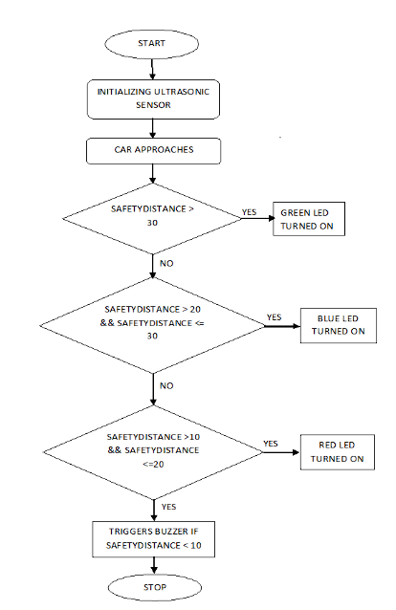

**3.4 OUTPUT**

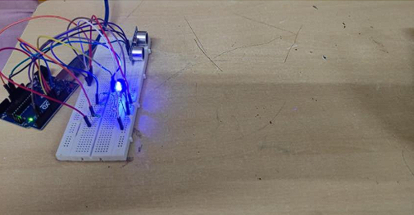

**Fig 1: Green LED indicates the safe zone**

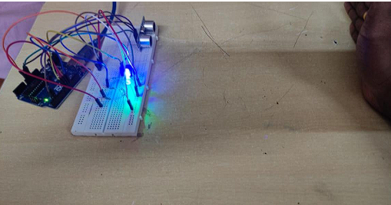

**Fig 2 : White LED indicates the warning zone**

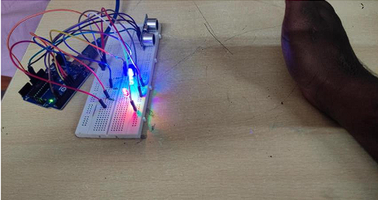

**Fig 3 : Red LED and Buzzer indicates the stop zone**

.

**CONNECTIONS:**

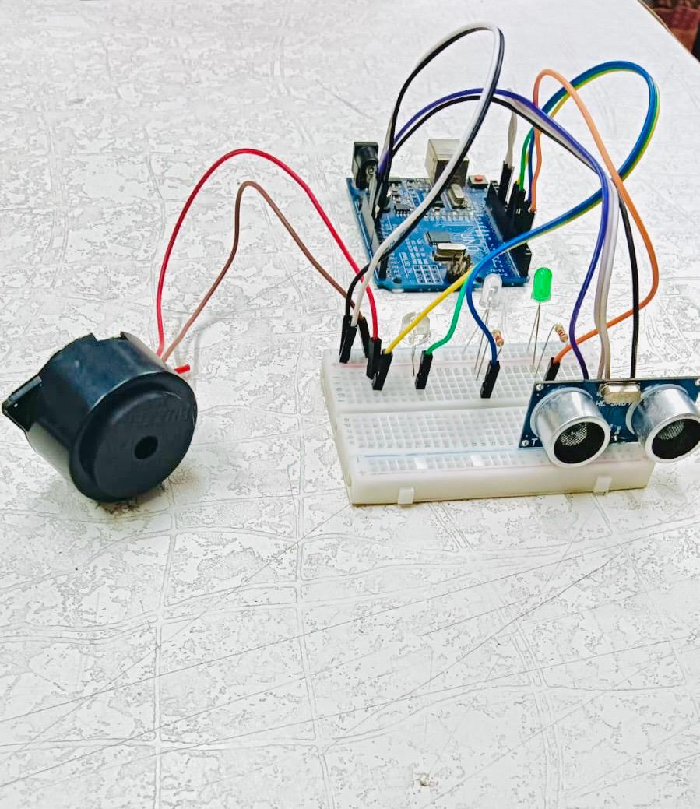

**CHAPTER 4**

**CONCLUSION AND FUTURE WORK**

Although science and technology have developed and evolved a lot and with the enlargement of automobile field, the number of owned vehicles are rapidly

increasing which in turn increases accidents in which 40% of accidents or damages are caused while parking the vehicles. This simple design of Reverse Car parking system using arduino and ultrasonic sensor which calculates the distance between the car and the obstacle that can be indicated by using LEDs and Buzzer which provides a safe way to park the vehicles without any damage or accidents. In future, It will help to automatically adjust vehicles in the parking area to park and retrieve our vehicle without need of human intervention.

11

**APPENDIX I**

const int trig = 12;

const int echo = 13;

const int buzzer = 8;

const int LED1 = 2; // Long distance

const int LED2 = 3; // Medium distance

const int LED3 = 6; // Very close distance

int duration = 0;

int distance = 0;

void setup()

{

pinMode(trig , OUTPUT);

pinMode(echo , INPUT);

pinMode(buzzer, OUTPUT);

pinMode(LED1 , OUTPUT);

pinMode(LED2 , OUTPUT);

pinMode(LED3 , OUTPUT);

Serial.begin(9600);

}

void loop()

{

digitalWrite(trig , HIGH);

delayMicroseconds(1000);

digitalWrite(trig , LOW);

duration = pulseIn(echo , HIGH);

distance = (duration / 2) / 28.5;

Serial.println(distance);

if (distance <= 10)

{

digitalWrite(LED3, HIGH);

digitalWrite(buzzer, HIGH);

digitalWrite(LED1, LOW);

digitalWrite(LED2, LOW);

}

else if (distance > 10 && distance <= 20)

{

digitalWrite(LED2, HIGH);

digitalWrite(LED1, LOW);

digitalWrite(LED3, LOW);

digitalWrite(buzzer, LOW);

}

else

{

digitalWrite(LED1, HIGH);

digitalWrite(LED2, LOW);

digitalWrite(LED3, LOW);

digitalWrite(buzzer, LOW);

}

}

13

**REFERENCE**

**1.** Engr.Farman Ali, Engr.Muhammad Athar Suri, Engr. Noman Muslim,

Engr.Shareef Ullah Khan, Engr.Muhammad Ayman Iqbal, “ n7Use of

Modern Technology in Reverse Car Parking System”, International Journal

of Computer Engineering and Information Technology,VOL. 8, NO. 3,

March 2016.

**2.** Patil VedantBhausahebJayashri, Sawant Sarvesh Shashikant Smruti,

PhodkarParth Prashant Priyanka,Arakade Aditya Vijay Chhaya, Prof.

Santosh Kamble, Ms. Anita S. Nalawade, “Reverse Car Parking Sensor”,

International Research Journal of Engineering and Technology (IRJET),

Volume: 08 Issue: 04, Apr 2021.

**3.** Yousif Allbadi, Jinan N. Shehab, Musaab M. Jasim, “The Smart Parking

System Using Ultrasonic Control Sensors”, IOPConference Series: Materials

Science and Engineering, February 2021.

**4.** Jenli Susilo, Anita Febriani, UciRahmalisa, Yudha Irawan, “Car Parking

Distance Controller Using Ultrasonic Sensors Based On Arduino Uno”,

Journal of Robotics and Control (JRC), Volume 2, Issue 5, September 2021.

**5.** ElakyaR, Juhi Seth, Pola Ashritha, R Namith, “Smart Parking System using

IoT”, International Journal of Engineering and Advanced Technology

(IJEAT), Volume-9 Issue-1, October 2019.

**6.** G. Revathi, V.R.Sarma Dhulipala, “Smart parking systems and sensors: A

survey”, International Conference on Computing, Communication and

Applications (ICCCA), February 2012